**S3**

1. **Use the S3 browser console to create a bucket that is unique to the region**

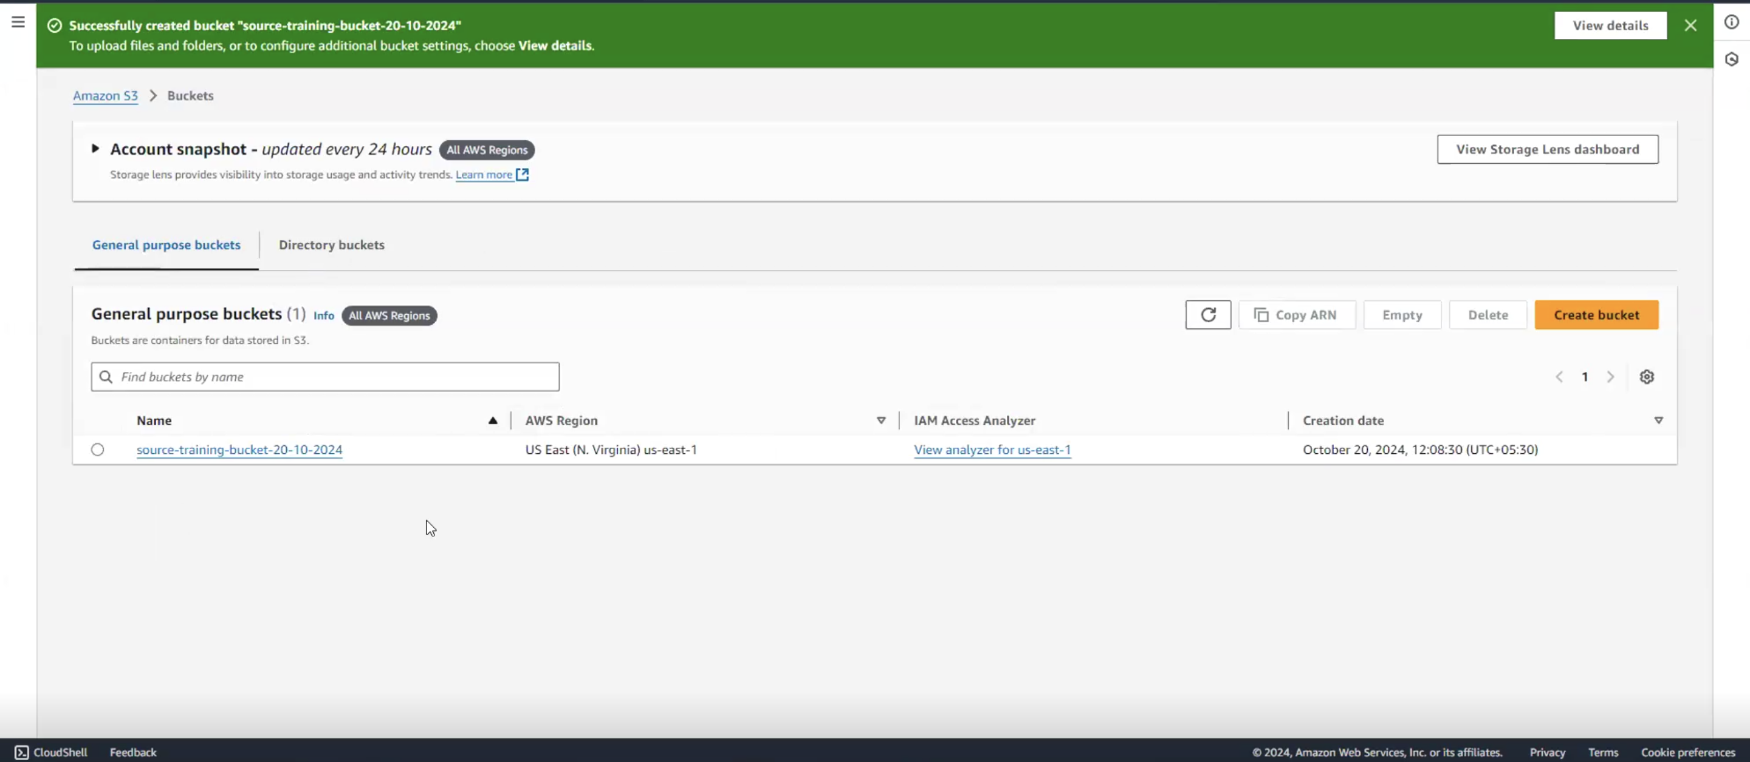

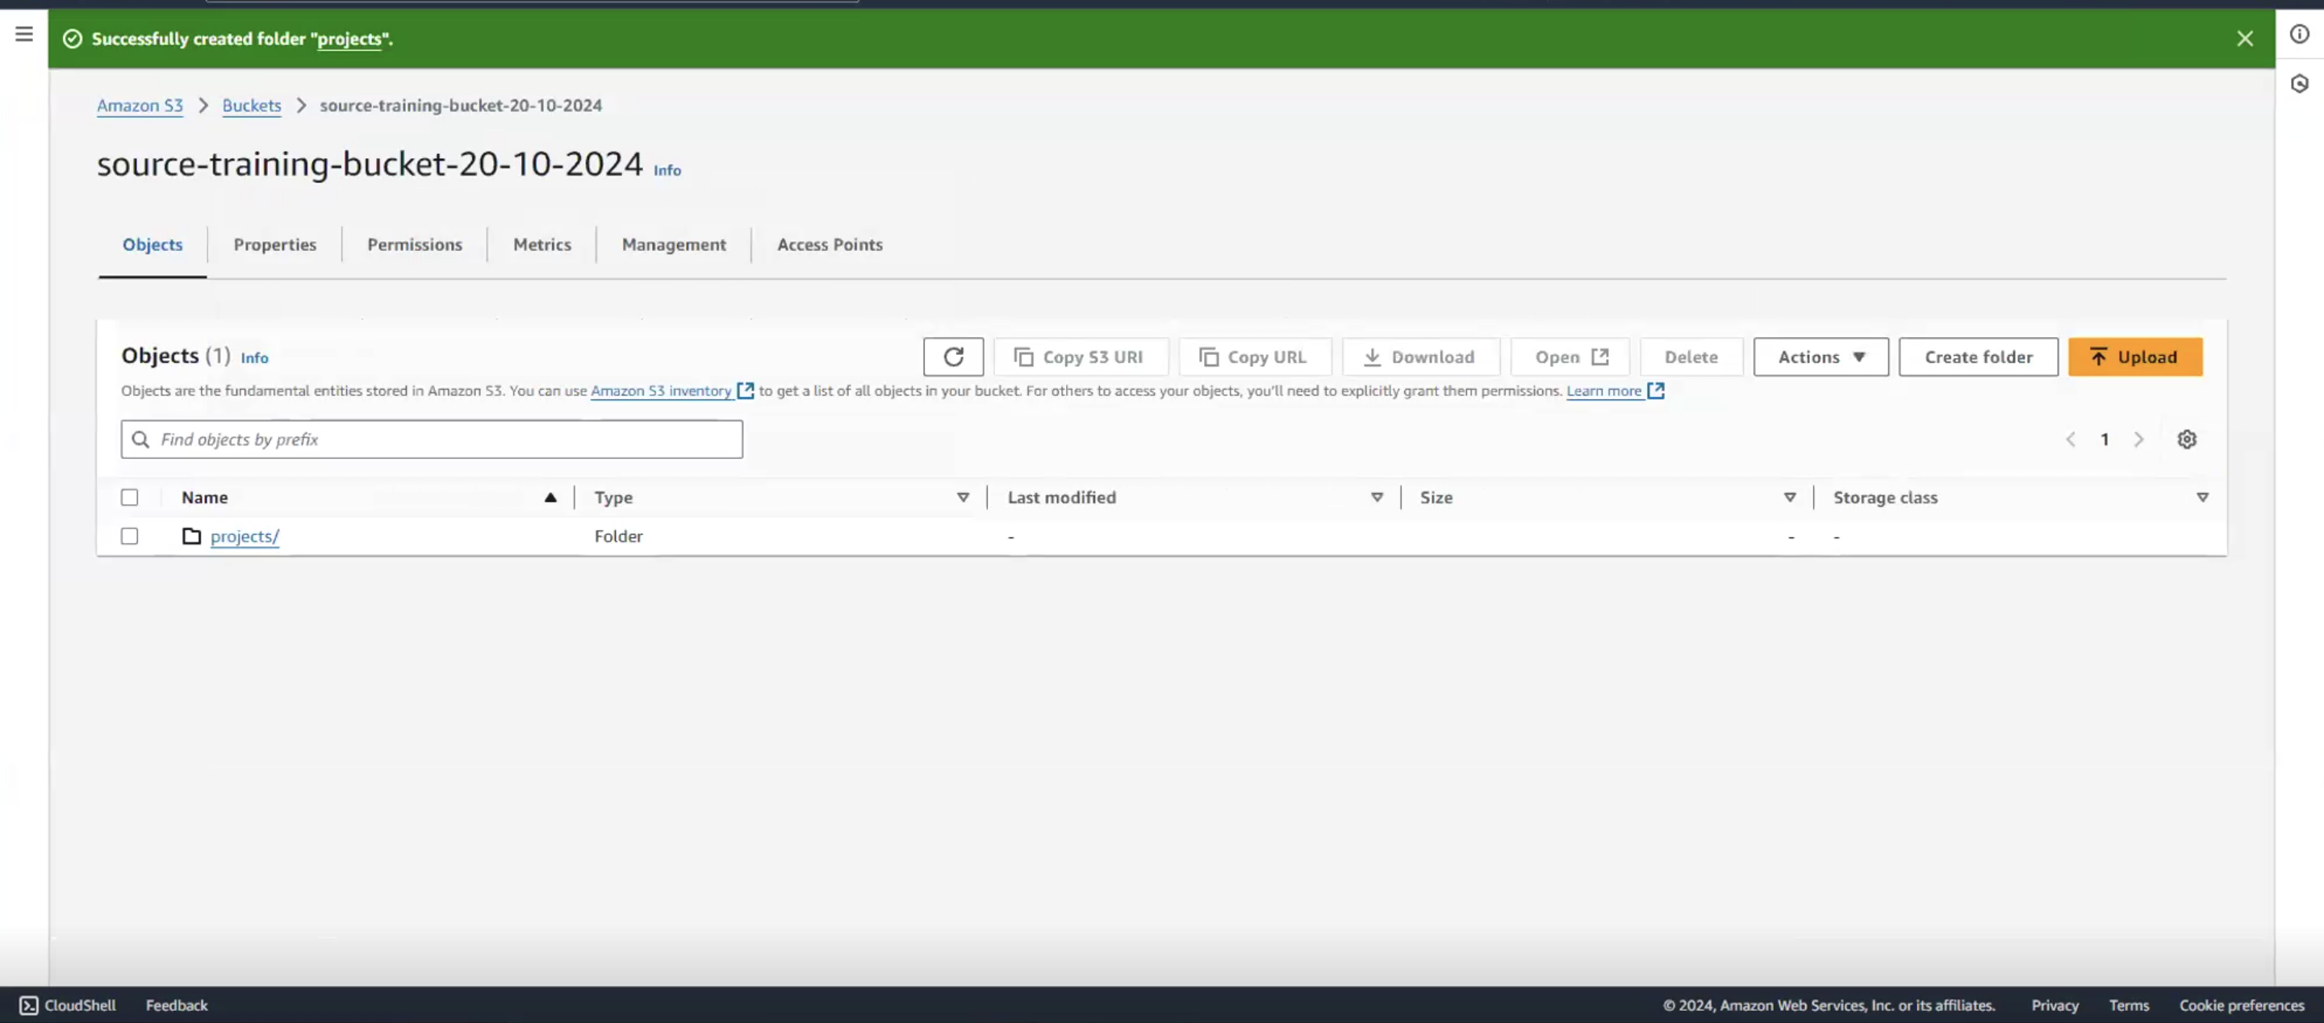

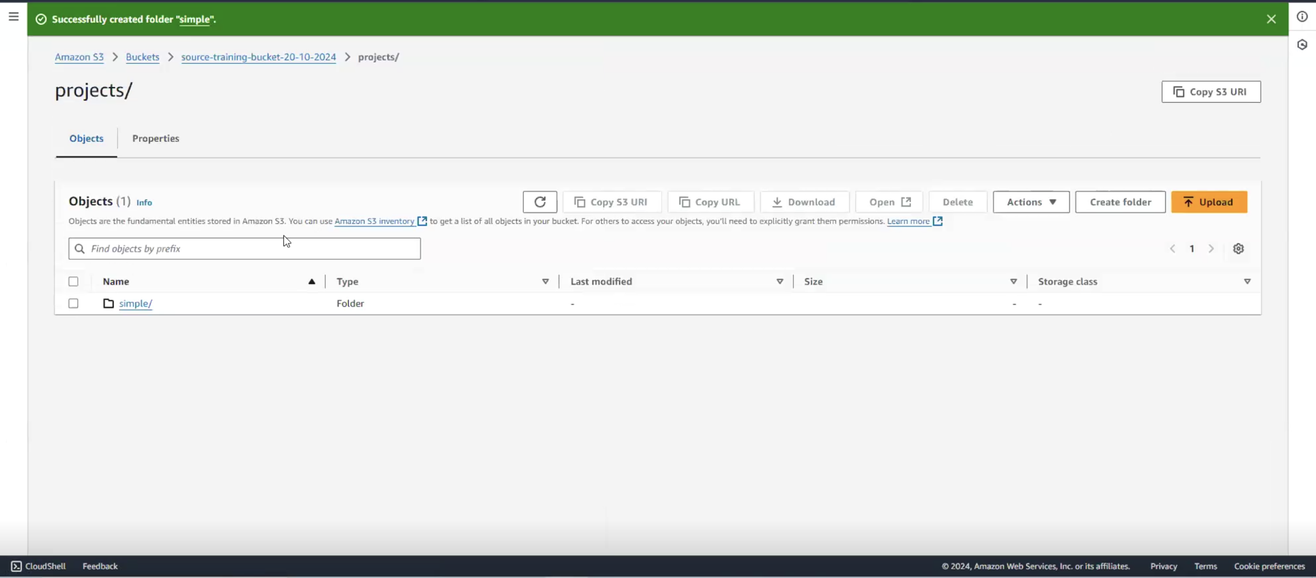

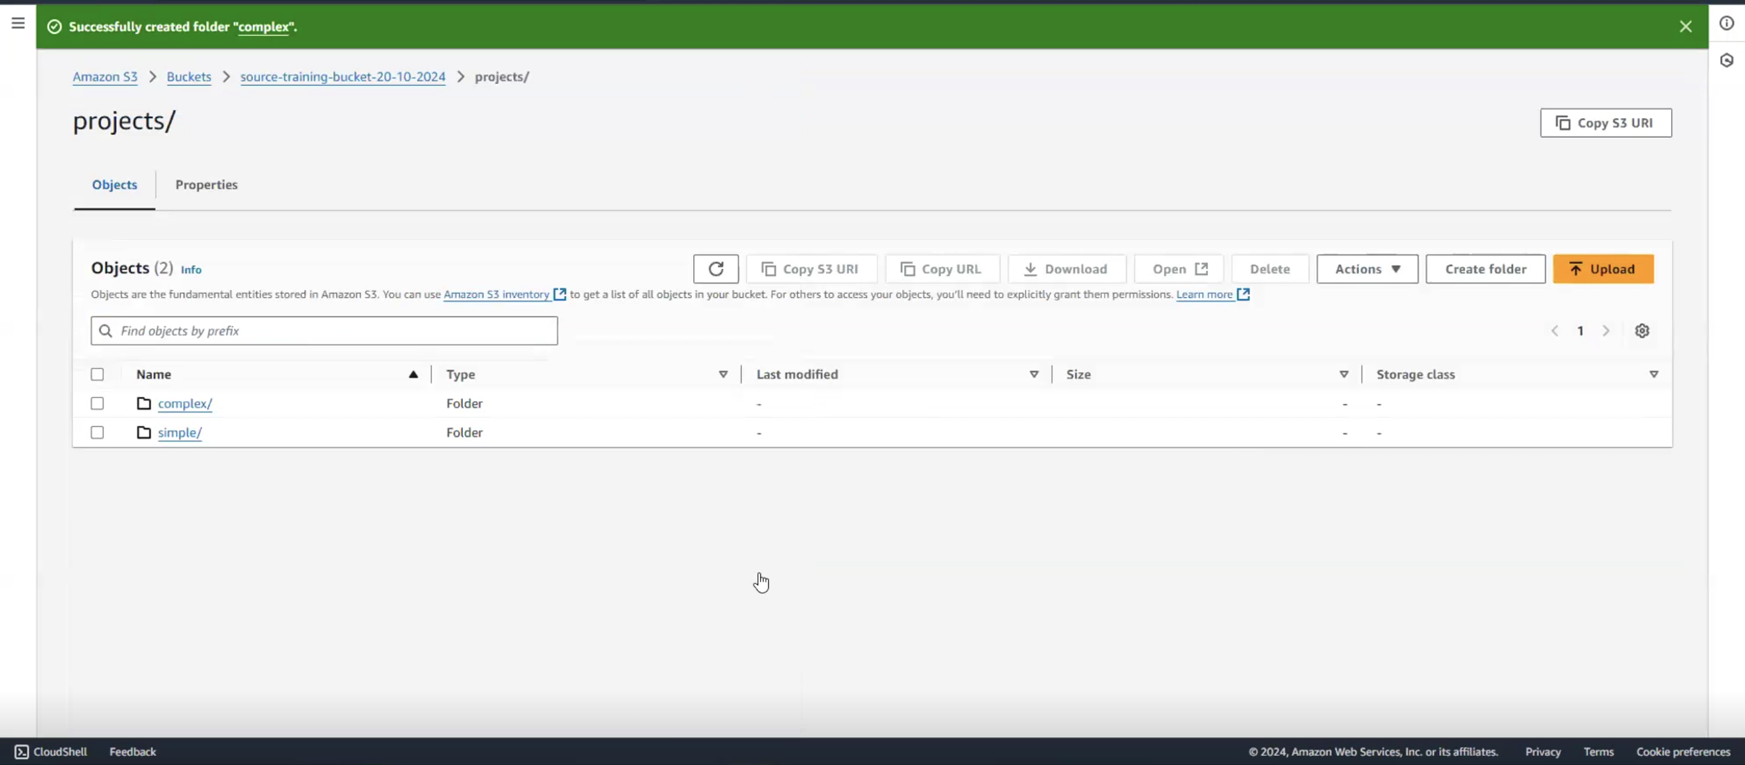

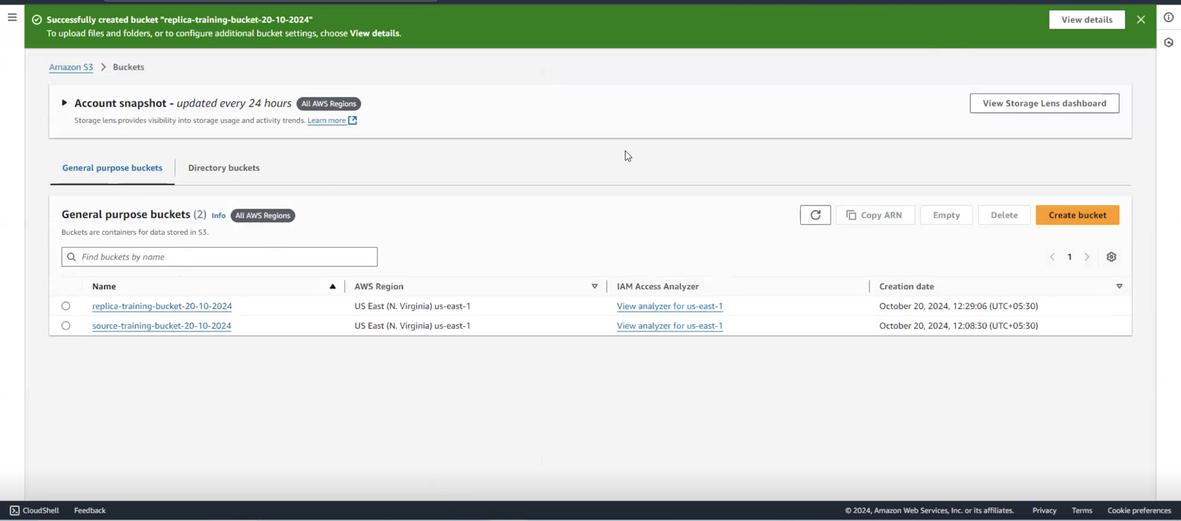

1. **Use the CLI to**
2. **Upload a few (non sensitive) files from your local machine to S3 bucket**

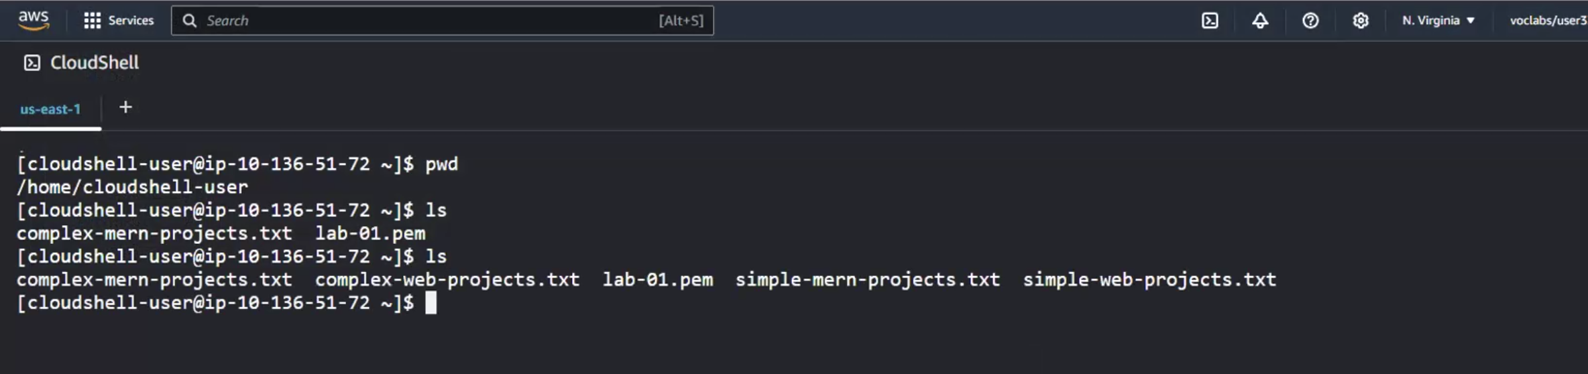



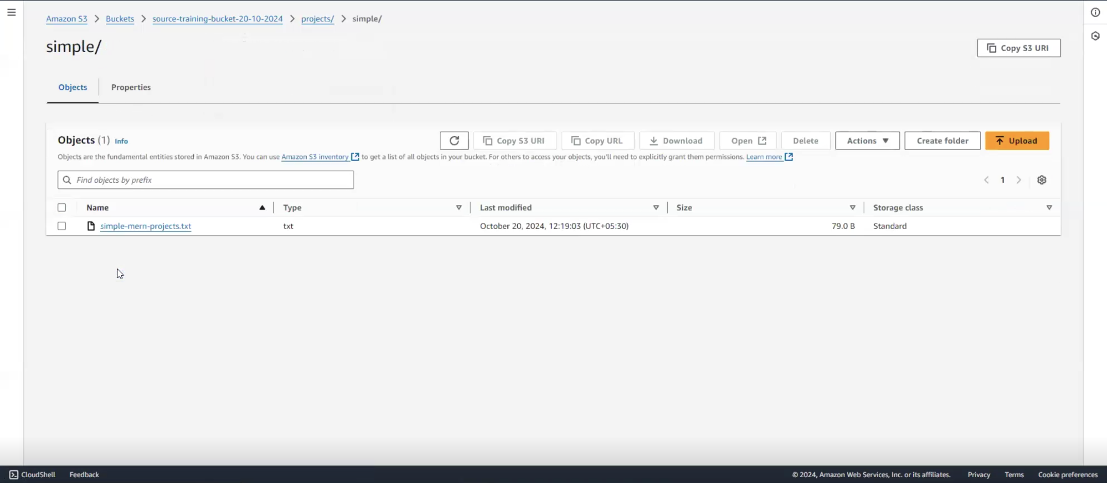



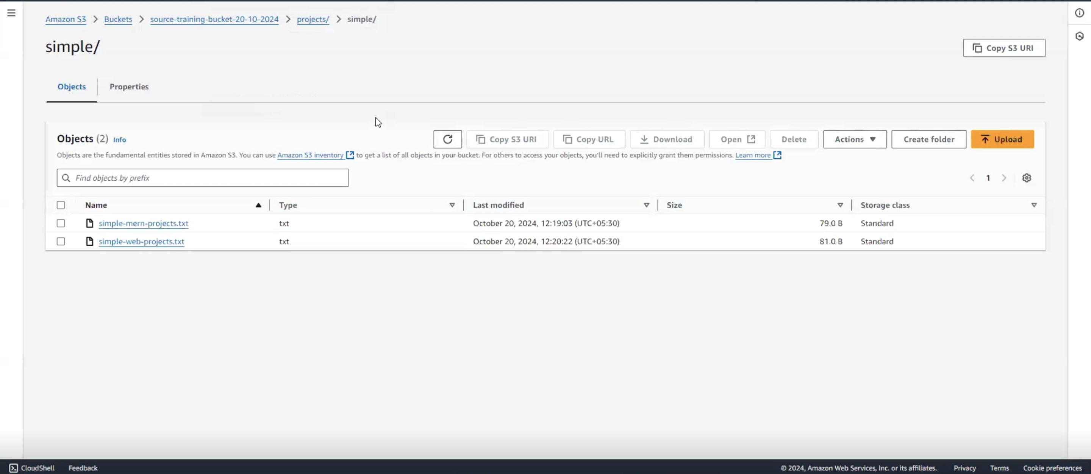





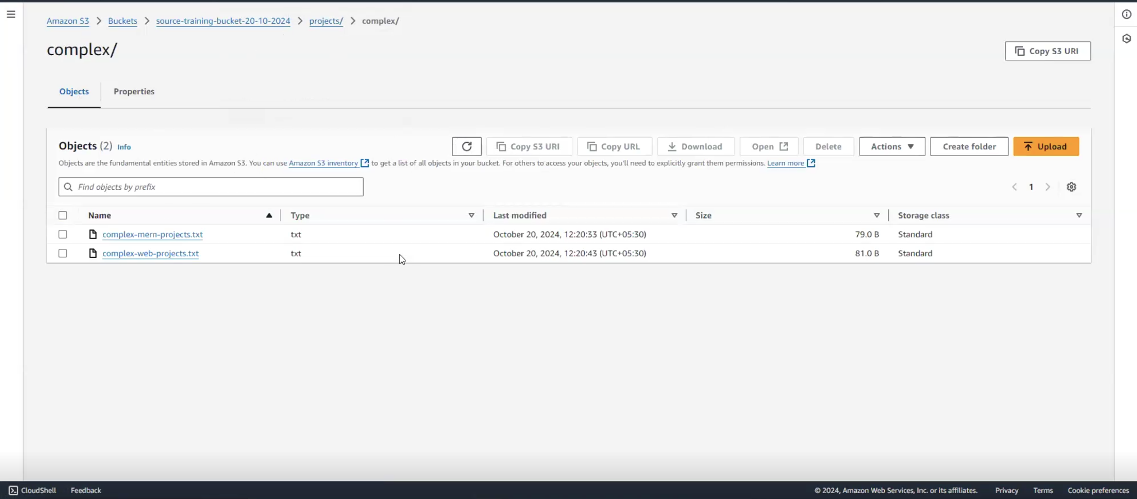

1. **List the buckets**

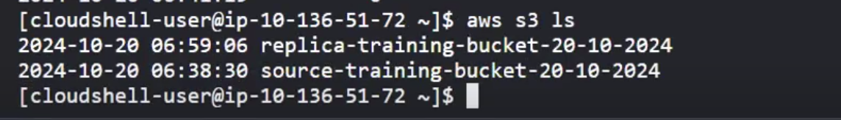

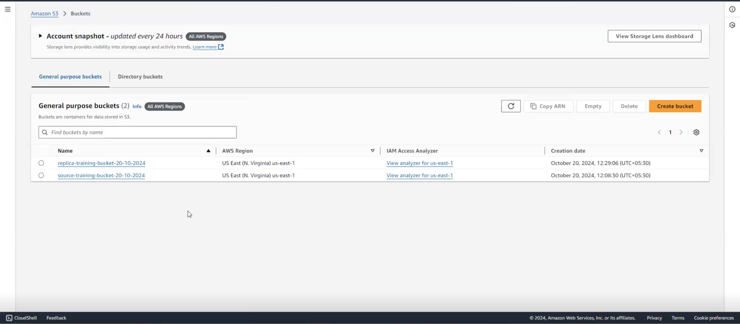

1. **List the contents of a bucket**



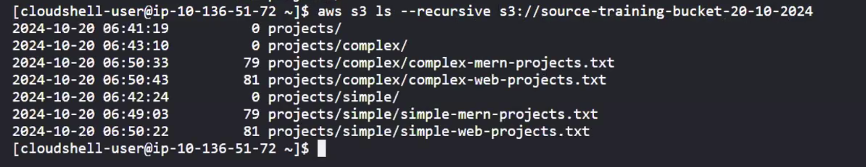

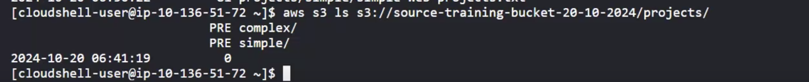

1. **Enable versioning of the bucket**

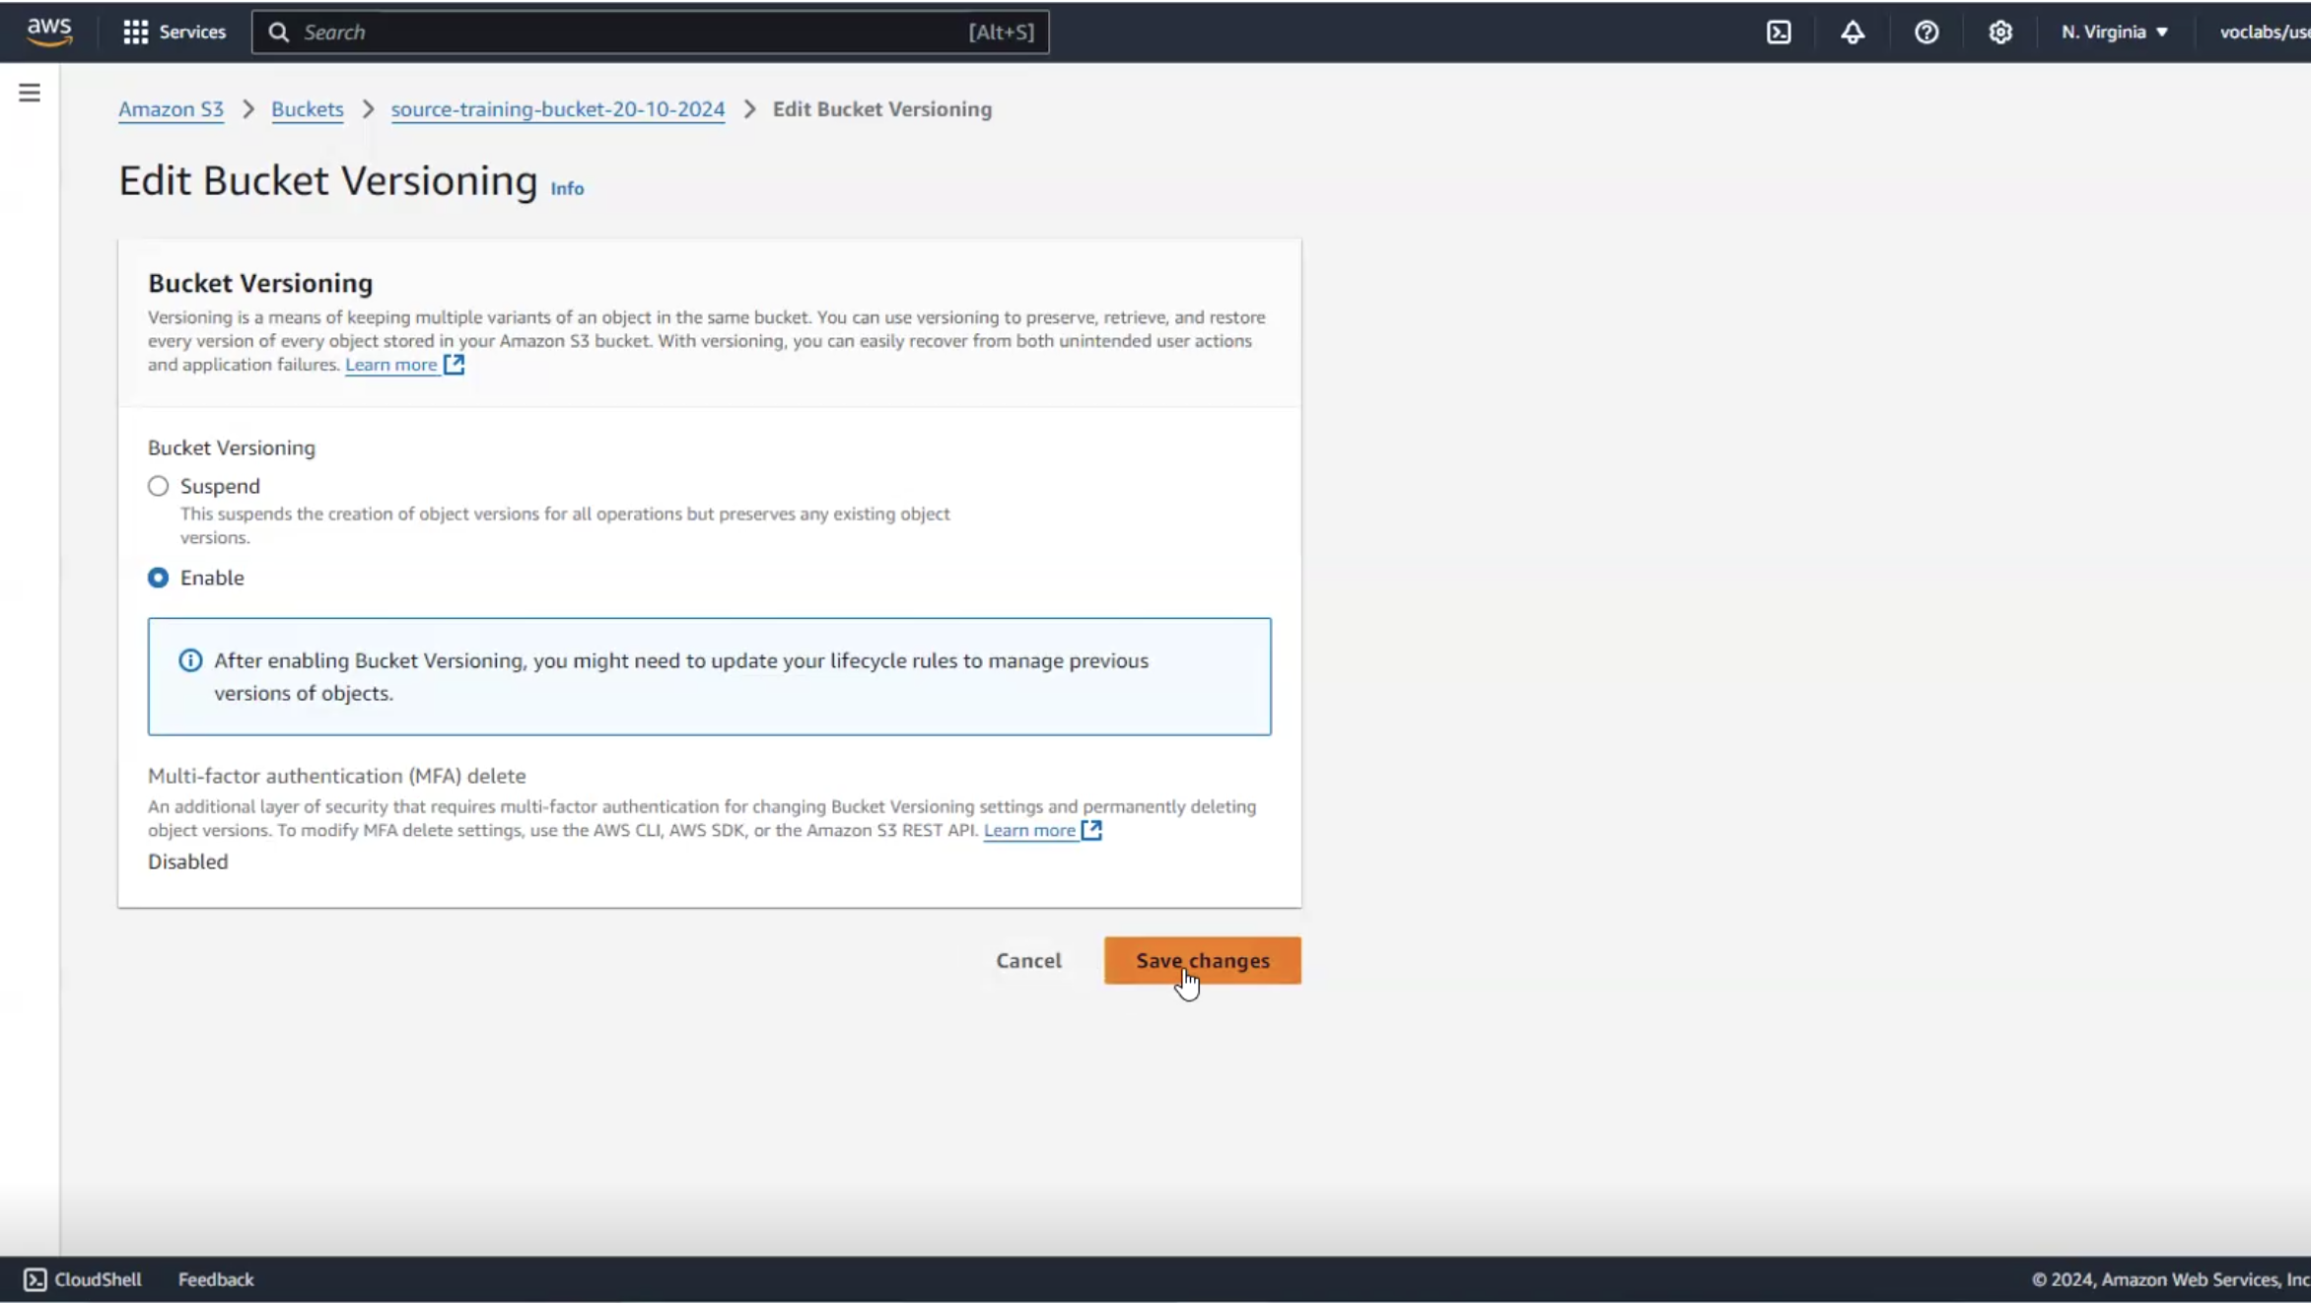

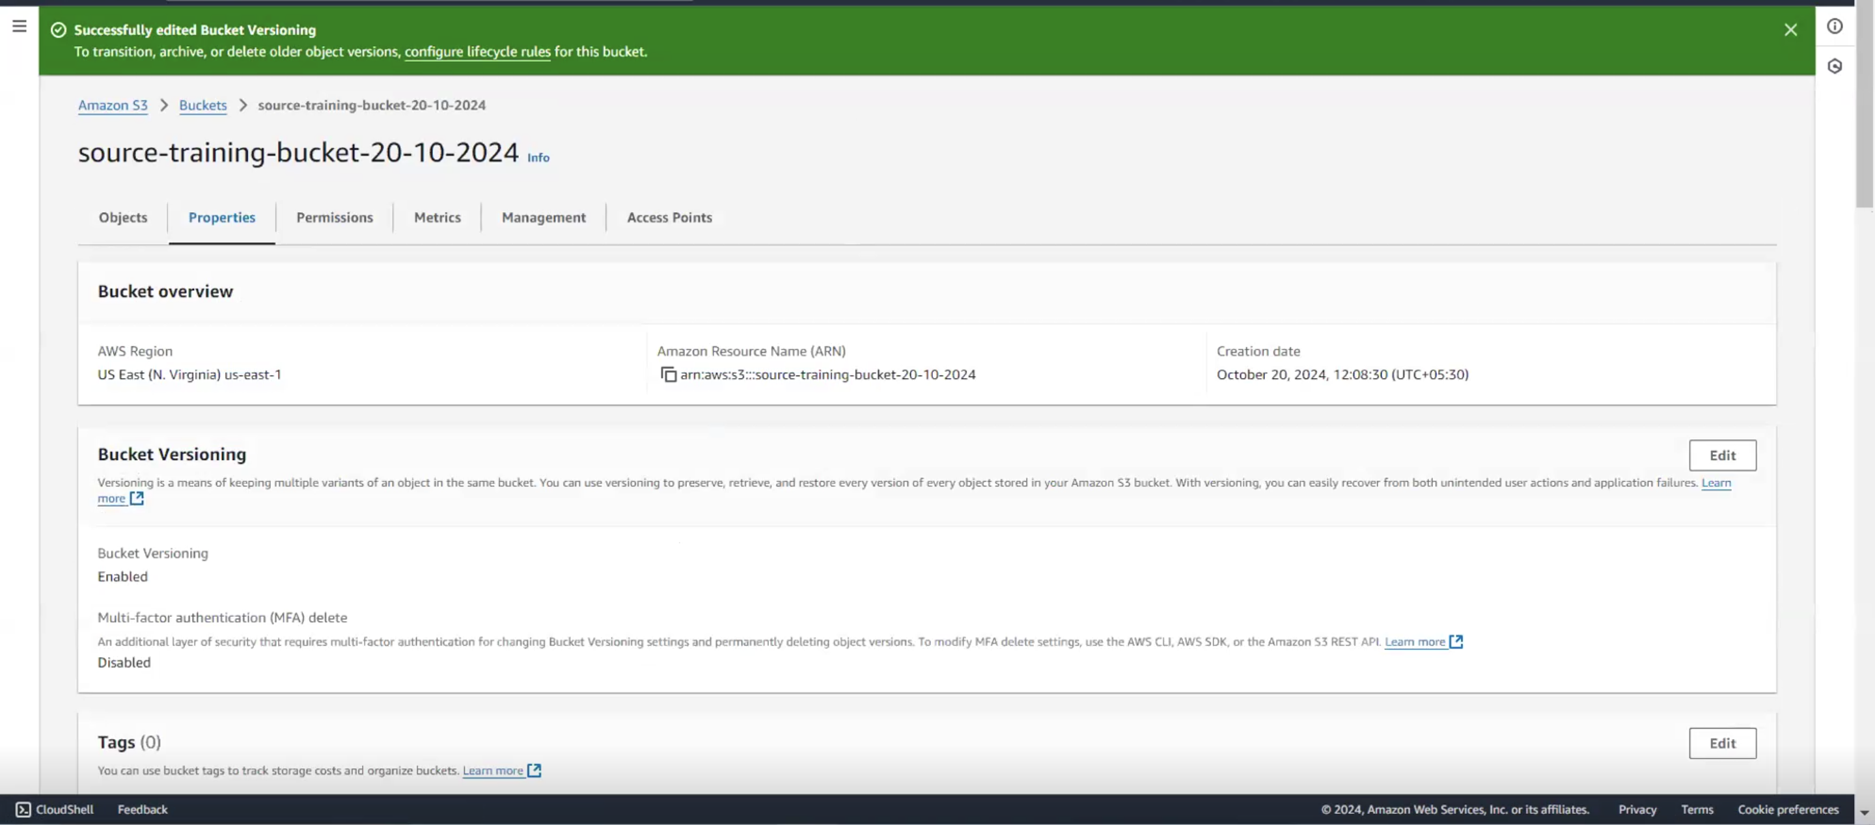

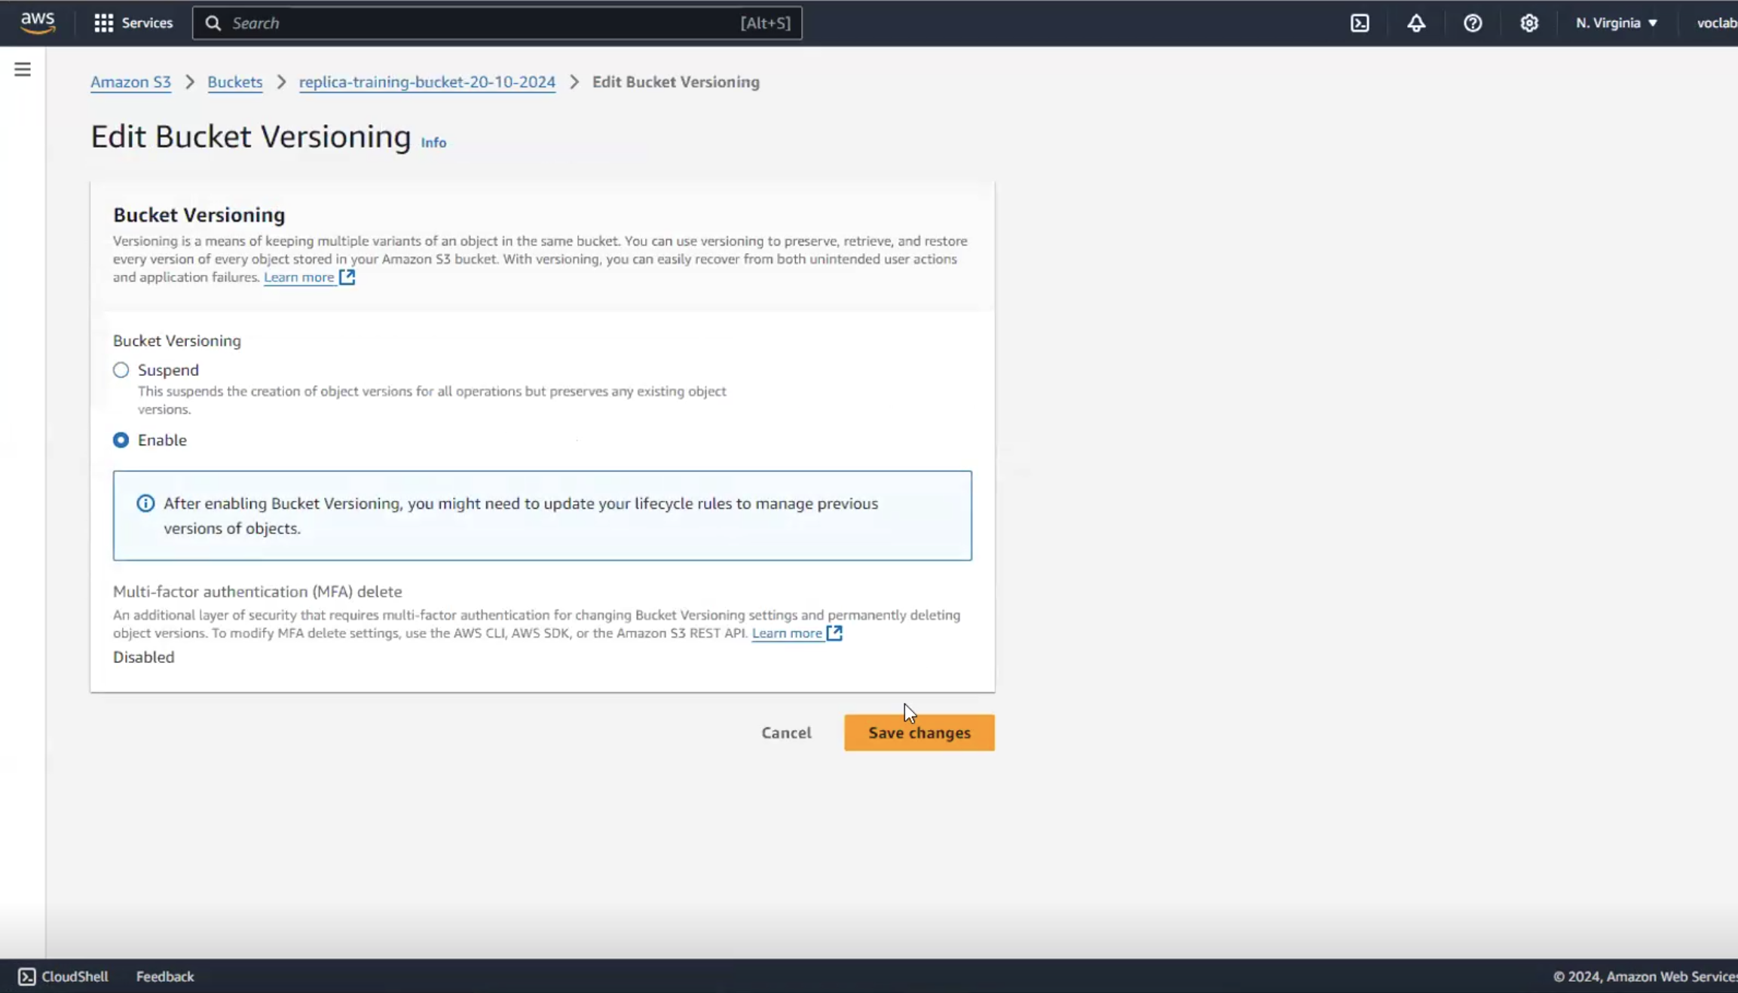

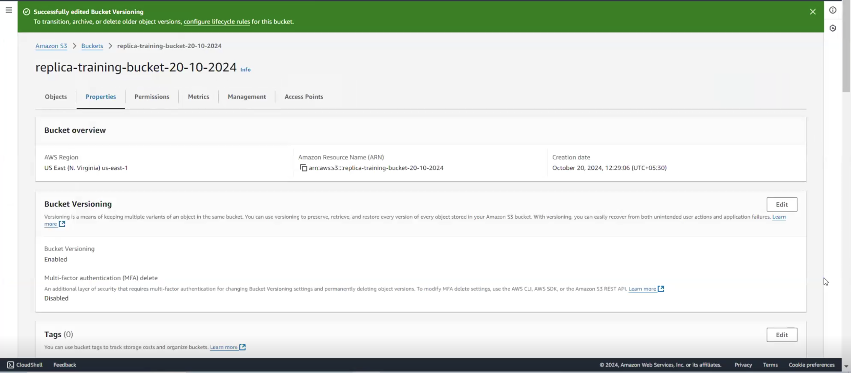

1. **Enable cross region replication**

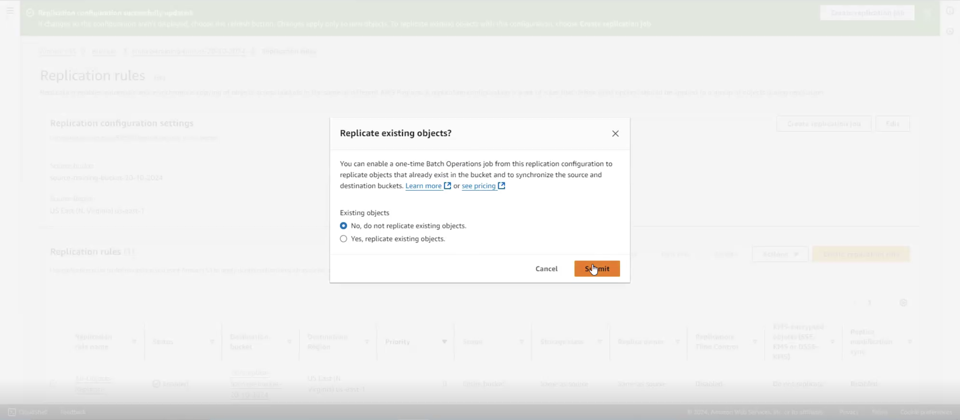

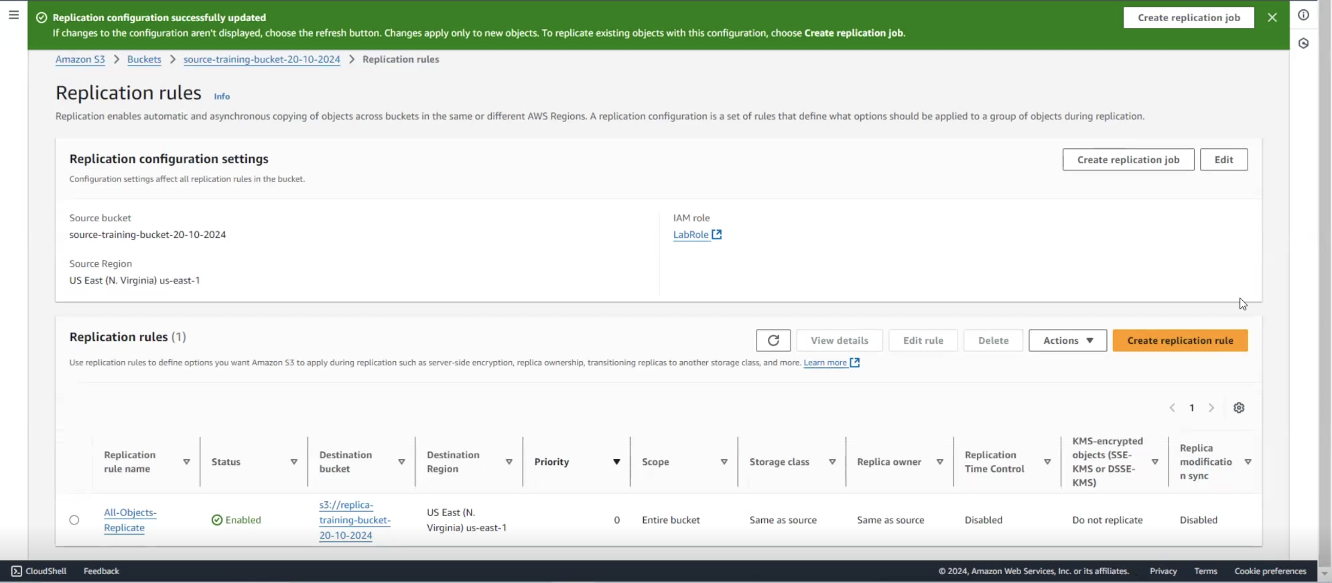

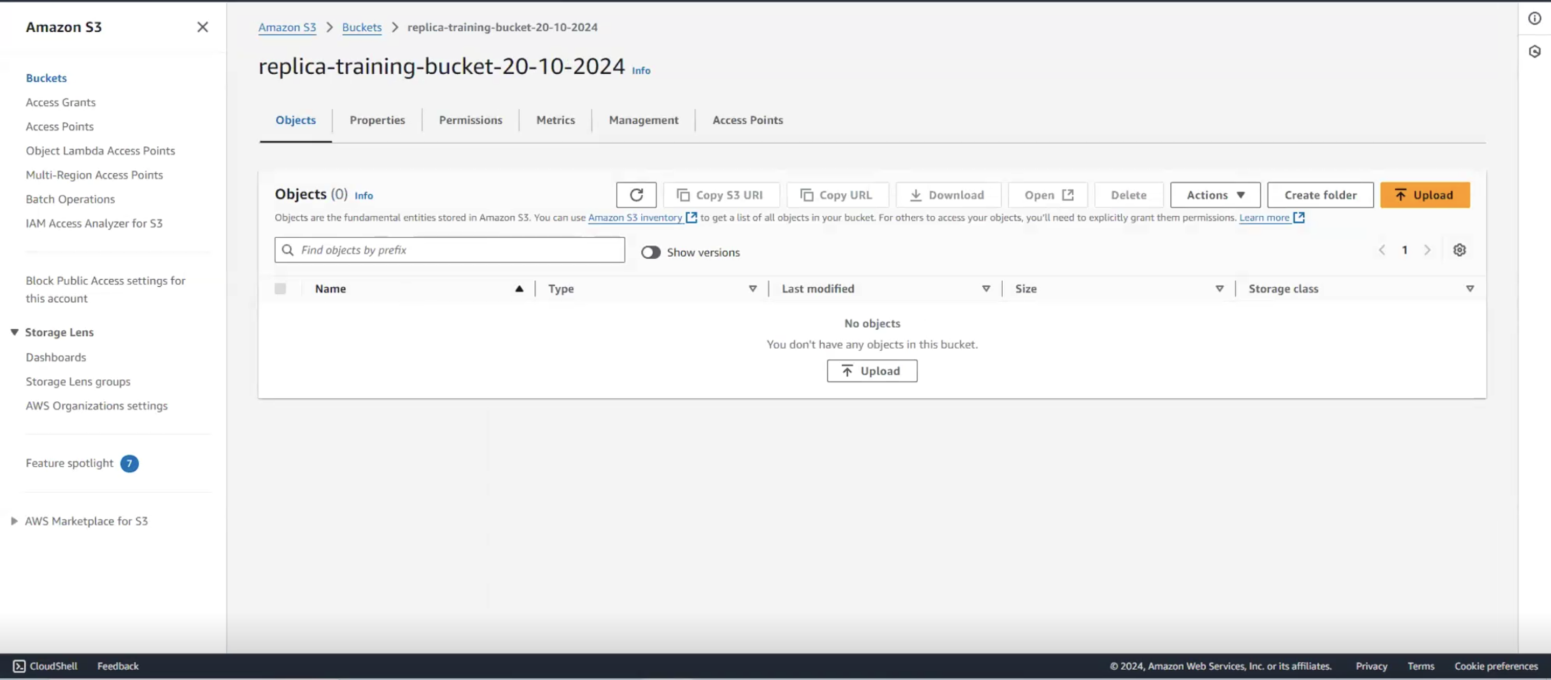

1. **Q: State your observations of the existing objects (are they replicated?)**

**Sol: Whatever object is there in the source bucket before the replication rule was created, they will not be a part of S3 replication process.**

**All the objects which are existing there in the bucket currently before the rule was, we are creating the rule only now, right when the rule is after the replication rule is created, only any new object which has been created in the bucket, only that will be replicated onto the replica bucket.**

**After replication rules were created, a window popped-up asking if we want to replicate existing objects as a part of a batch process outside the scope of history. We did not go ahead with it, so we chose the default option, i.e., “No, do not replicate existing objects.”**

**Hence, we will not replicate existing objects, as that will separately run as a batch process which we are not interested.**

1. **Use the CLI, upload a few new files to the same bucket**





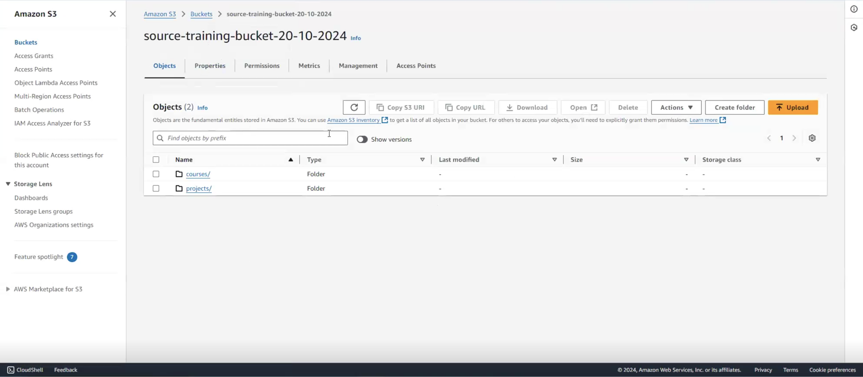

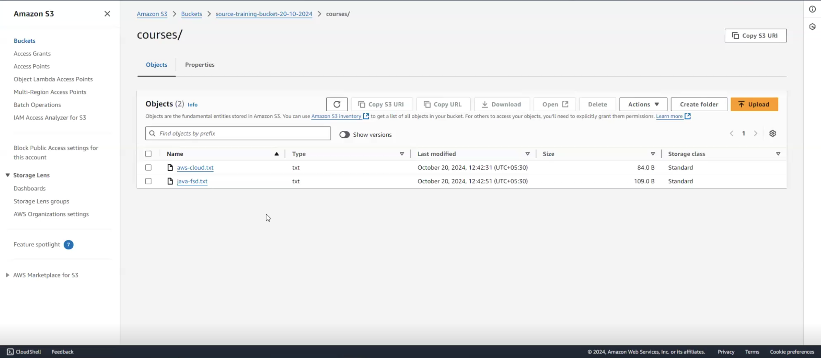

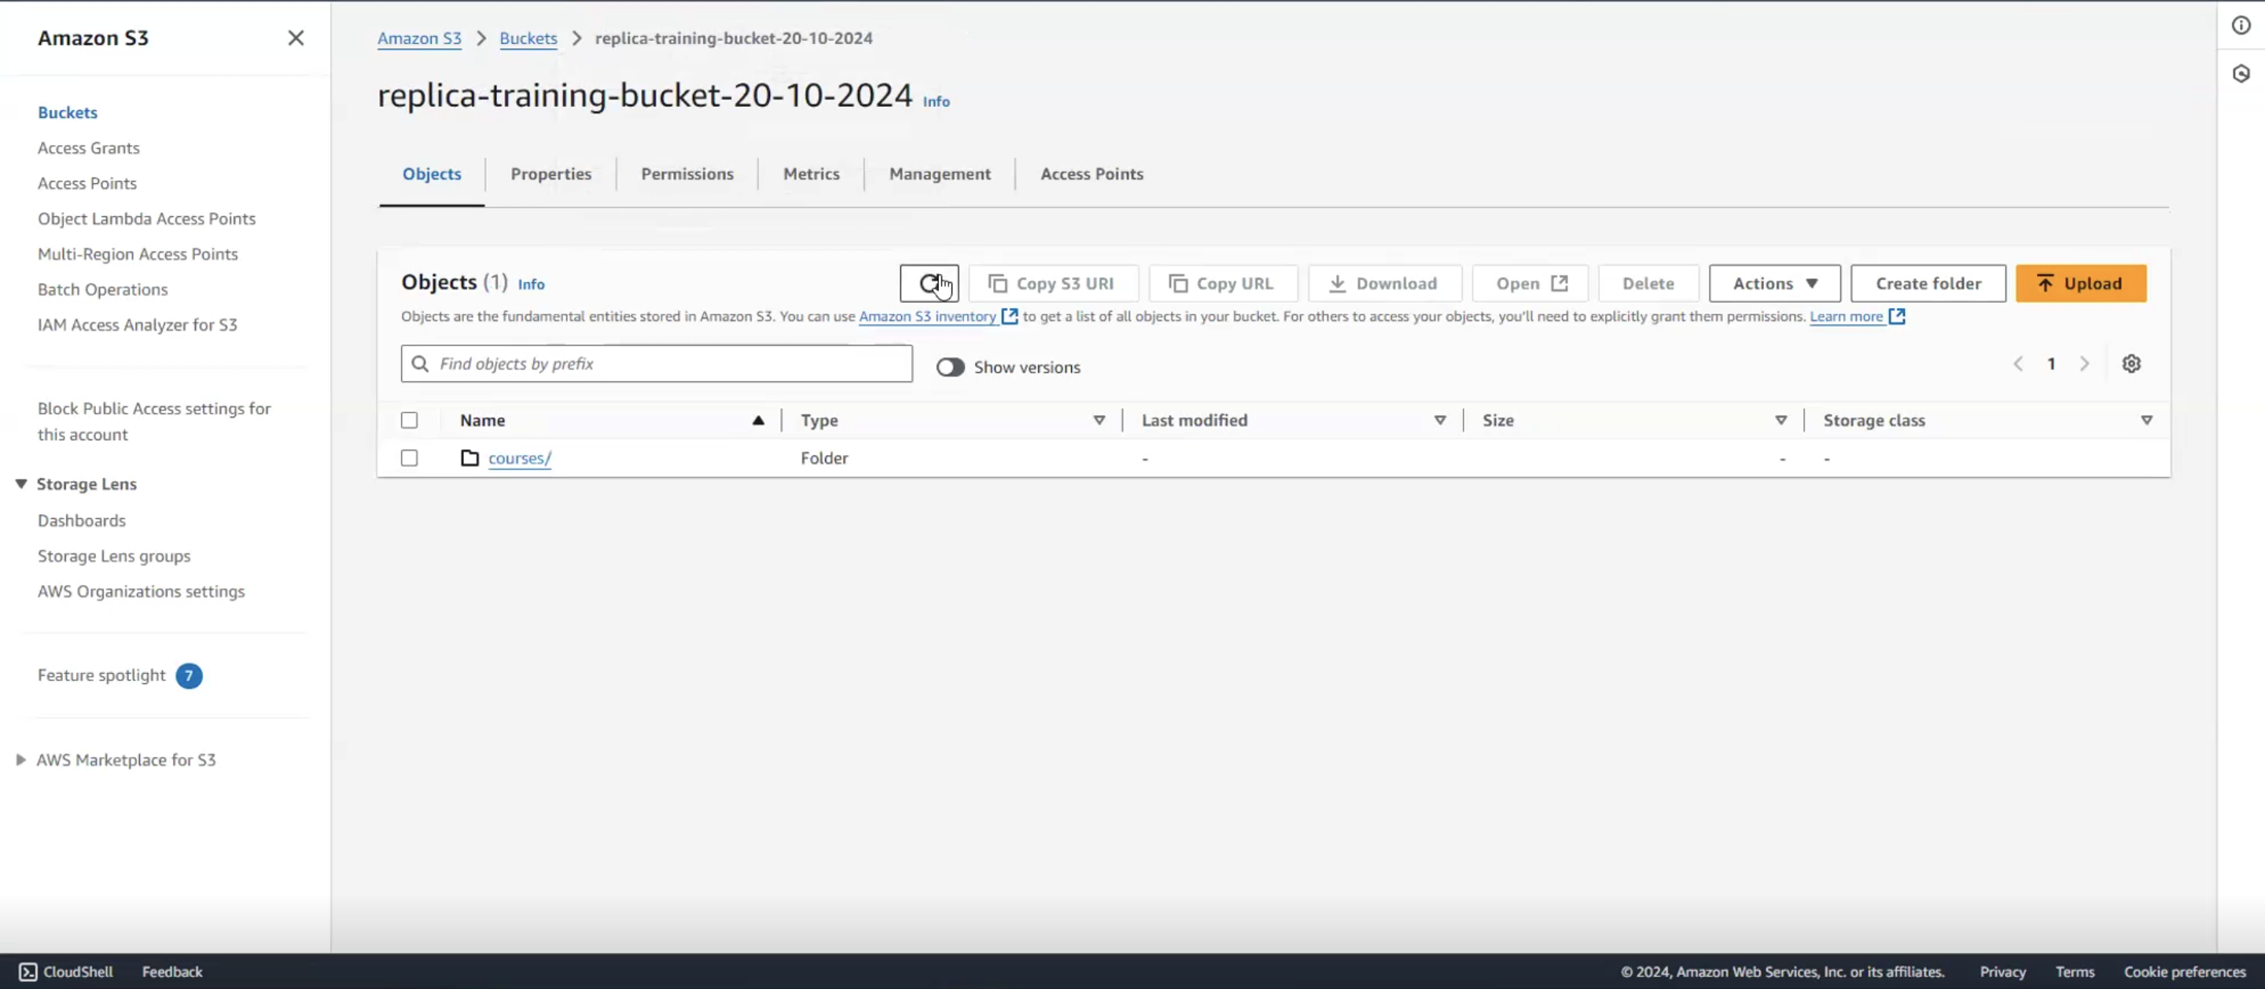

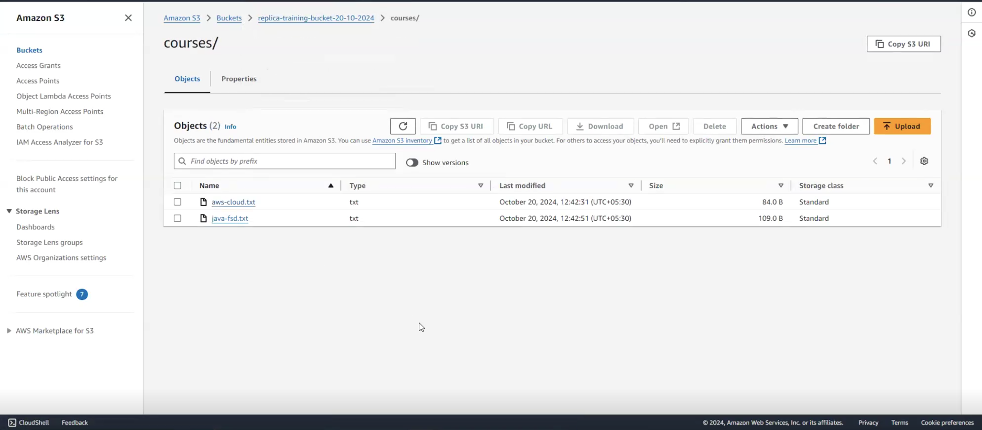

1. **Q: State your observations of the new objects**

**Sol: After the replication rule has been added to the source bucket, new objects created or added to the source bucket will be considered for replication.**

**Objects added after the replication was created, were replicated onto the target replica bucket.**

1. **Clean-Up Part of S3 bucket or Removing Objects from S3 Bucket**





